**Spring 2017 update**

Hello all,

A quick update on events so far…

Firstly – A BIG thank you to everyone for their kind thoughts and wishes with regards to my health. I am very much on the mend and have now begun my phased return as hoped.

Once again the children have returned from their break refreshed and ready to work hard. Already this term we have held our annual Inter Faith Week (please feel free to come and see the displays next week) and celebrated Education Sunday at Church. As usual, we anticipate lots of exciting things to look forward to over the next few months (especially lighter mornings and evenings)and as usual, we have included dates for your diaries at the bottom of this newsletter.

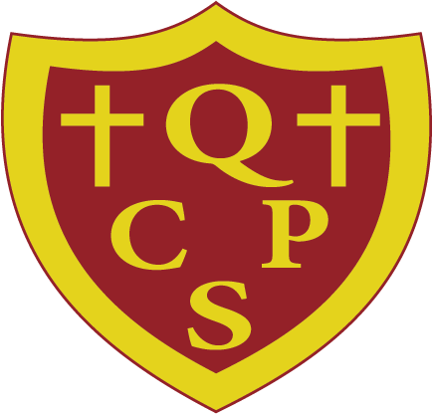Quinton Church Primary School.

On 1st January 2017, Quinton Church Primary School became part of the Barchelai Multi Academy Trust. The Trust consists of three schools; St Michael’s Church Primary School who we have worked alongside since September 2014 and Nonsuch Primary who we have helped to support since January 2016. We are very happy to be part of the Trust and we know we shall have a long and successful partnership with them.

[](https://www.google.co.uk/search?safe=strict&biw=1920&bih=910&tbm=isch&q=snowman+images&sa=X&ved=0ahUKEwjemJ6GvM7RAhUpL8AKHUDGCtYQhyYIGw)

It may well be that the tiny flurry of snow we had last week is all we are getting this year but a reminder that in the event of adverse weather (and closure of the school) we shall send a text, put it on the website and on our facebook page and inform the local radio stations. With this in mind, please ensure we have the correct contact details for your child. We thank you for your co-operation.

[](https://www.google.co.uk/imgres?imgurl=http://www.studentsoftheworld.info/sites/family/img/46658_Diary.jpg&imgrefurl=http://www.studentsoftheworld.info/sites/family/loopylauren.php?Page%3D4&docid=4g0gBabjogfH7M&tbnid=K_jnrA3nrB1srM:&w=489&h=457&safe=strict&bih=910&biw=1920&ved=0ahUKEwigxcDh5qnMAhWL0hoKHYoADwEQMwhhKD0wPQ&iact=mrc&uact=8)Diary dates:

Tues 24th Jan – Literacy Morning

Wed 25th Jan – Birmingham City Mission Collective Worship

Thur 26th Jan – Badminton Competition at Bartley Green School

Mon 30th Jan – Fireman coming to visit year 4

Thur 9th Feb – Coffee Afternoon (details to follow)

Fri 17th Feb – Children break for half term

Mon 27th Feb – Children return to school

Wed 1st/ Thur 2nd March – Parent’s Evening (details to follow)

Mon 29th March – Year 5 Bikeability Week (details to follow)

Fri 7th April – Easter Assembly (details to follow)

Fri 7th April Break up

Mon 24th April – Teacher Day

Tue 25th April – Children return to school

Please note that the school will be closed on Thur 4th May for voting. For this reason we shall use this day as our final Teacher Day.

As usual if you need anything please do not hesitate to contact either myself or Mrs Bruten

Samantha Cosgrove

Executive Head Teach+er